Table of Contents

Introduction 2

Vision behind NeoSnap 2

Prerequisites 2

Getting Started 3

Step 1: Ordering Parts 3

Step 2: Prepare the monitor 3

Step 3: Build the Circuit 3

Step 4: Setup Raspberry Pi 3

Step 5: Download Git Repository 4

Step 6: Final setup on Raspberry Pi 4

References 4

# Introduction

## Vision behind NeoSnap

NeoSnap is a device that was created by LSRC Consulting for Enlace as a senior design project at the University of Illinois at Chicago. The goal of this project was to provide Enlace a better and cheaper alternative to a mobile application that simulated a photo booth. At LSRC, we strive for excellence and innovation so we took the idea one step further by including Enlace’s mission in our final product.

Enlace is dedicated to creating a positive impact on the lives of Little Village residents and we felt one way to positively impact the students of Little Village was to give the community a small peek into the STEM fields (Science, Technology, Engineering, and Mathematics) by showing how fun and interesting it can be to build a new product. Our goal with the NeoSnap was to make a smart product that fulfills all of the requirements of the photo booth product, but also document the process to the point where a high school with little to none experience with programming or electrical engineering can replicate it while learning how to code, make a schematic, and familiarize themselves with Computer Aided Design.

## Prerequisites

This instruction manual has been tailored for the average high school student but we do recommend having the following prior to starting the project:

* All required parts from the provided parts list
* Clean work area free of clutter
* Basic understanding of
  + Operating Systems (Windows, OSX, Linux, etc.)
  + Python (see References section for tutorials and books)
* Internet (preferably wired – some wireless connections do not work well with the Pi)
* Computer with at least 1 USB port

# Getting Started

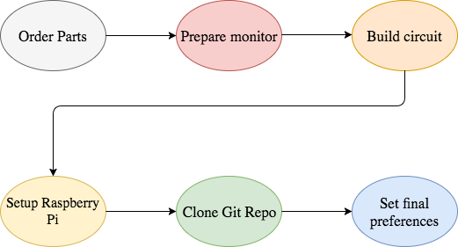

## Step 1: Ordering Parts

Although the code can be worked on prior to ordering the parts, it will not properly function until you have created the circuit first. Refer to the Parts List spreadsheet in the Documents folder to view and order the parts. Included are links to the website where we ordered them, but they can be brought from anywhere, even some brick and mortar stores such as American Science and Surplus.

## Step 2: Prepare the monitor

The monitor used in the original NeoSnap is a 10” touchscreen monitor from [www.element14.com](http://www.element14.com), but can be replaced with a larger or smaller monitor as long as it maintains the touchscreen functionality with the Raspberry Pi.

If you do not purchase the same monitor, the CAD dimensions for the case and LED diffuser will have to be re-measured



Allen will have to add some stuff into here.

## Step 3: Build the Circuit

## Step 4: Setup Raspberry Pi

## Step 5: Download Git Repository

## Step 6: Final setup on Raspberry Pi

# References

[Free Python tutorial on Codecademy](https://www.codecademy.com/learn/learn-python)

[Learn Python The Hard Way](Learn%20Python%20The%20Hard%20Way%203rd%20Edition%20V413HAV.pdf)